PRACTICAL TECHNICAL ASSESMENT

Hareeshma.S

NSTI Calicut

Activity 1

**Loading Different Image Formats for Computer Vision Tasks**

we'll learn how to load images of various formats using different Python libraries, including OpenCV, PIL (Pillow), and imageio. These libraries provide robust methods for handling images, which are essential for computer vision tasks.

Requirements

* Personal computer/laptop
* Google Collab

Procedure

* Loading Images with OpenCV

OpenCV is a powerful library for computer vision tasks. It reads images in BGR format by default.

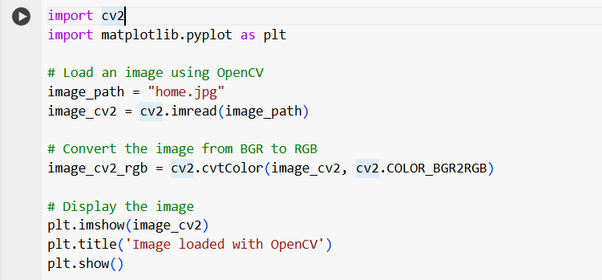

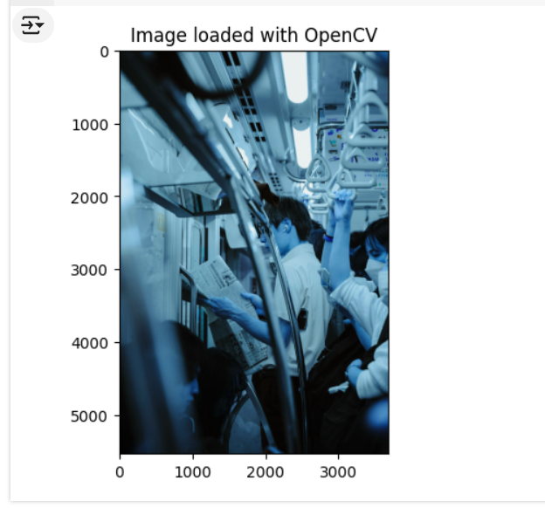

* Loading Images with PIL (Pillow)

PIL (Pillow) is a widely-used library for image processing in Python. It reads images in RGB format by default.

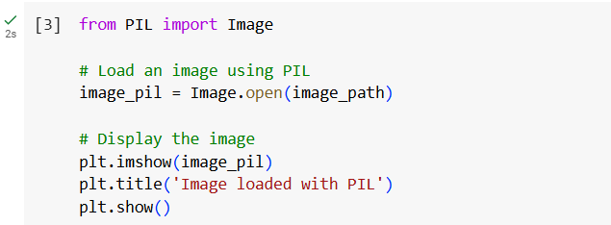

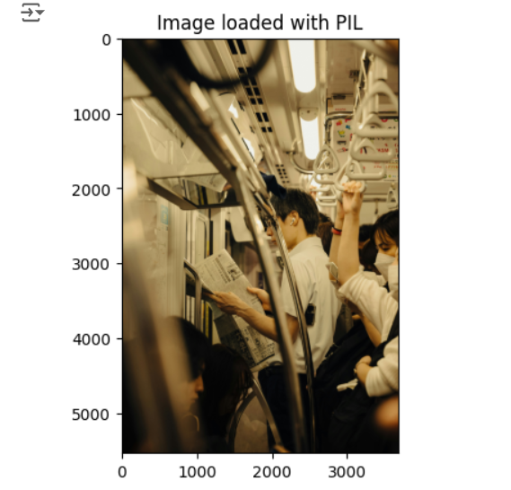

* Loading Images with imageio

imageio is another versatile library for reading and writing images in various formats.

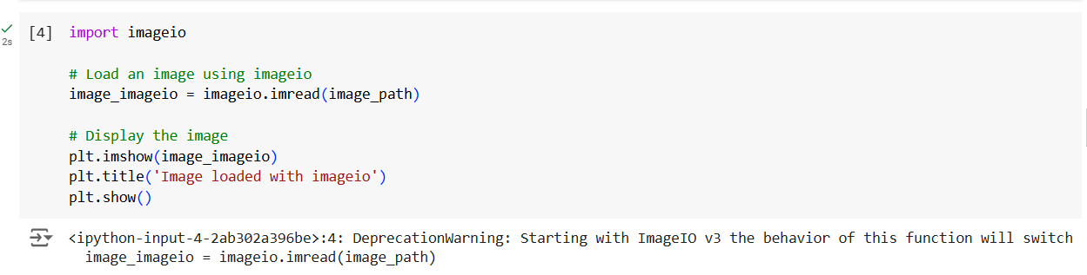

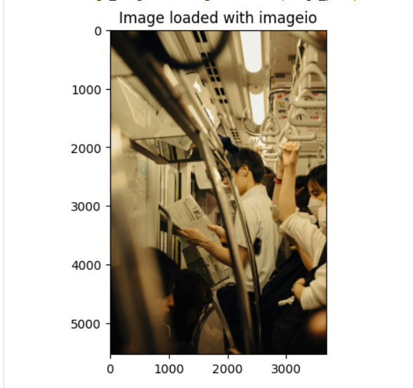

* Handling Different Image Formats

These libraries can handle various image formats such as JPEG, PNG, BMP, and more. Let's load images of different formats using each library.

Example with PNG Image

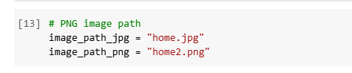

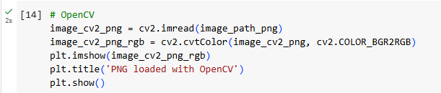

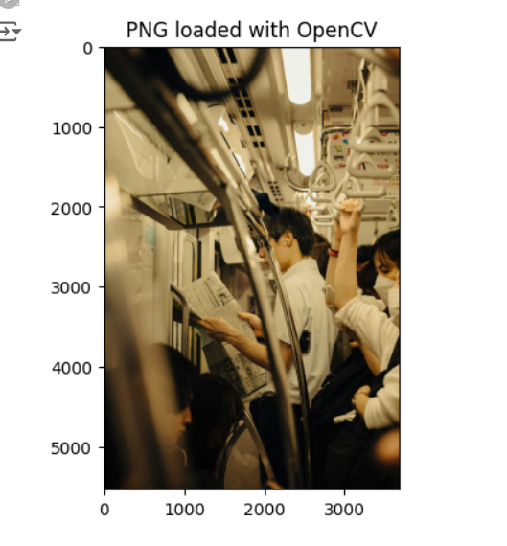

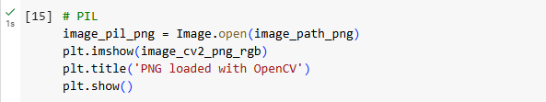

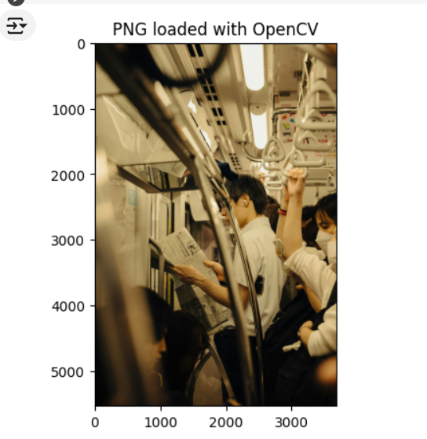

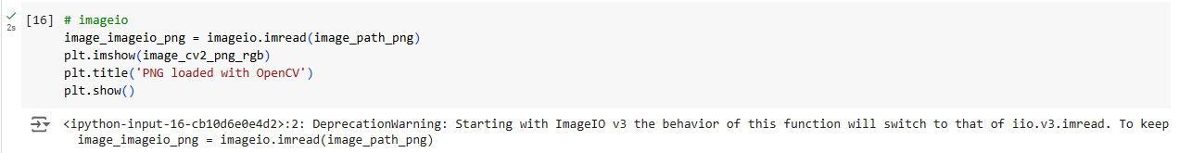

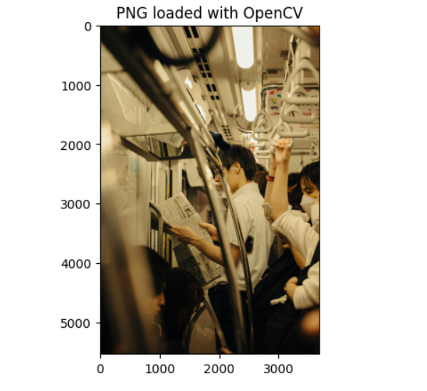

Activity 2

**Image Preprocessing Techniques**

Image Resizing, Cropping, and Rotation: Adjusts the size, shape, and orientation of images.

Requirements

* Personal computer/laptop
* Google Collab

Procedure

**Load the necessary library**

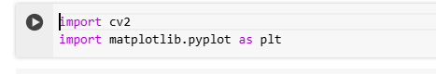

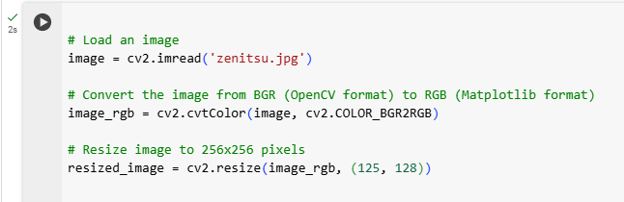

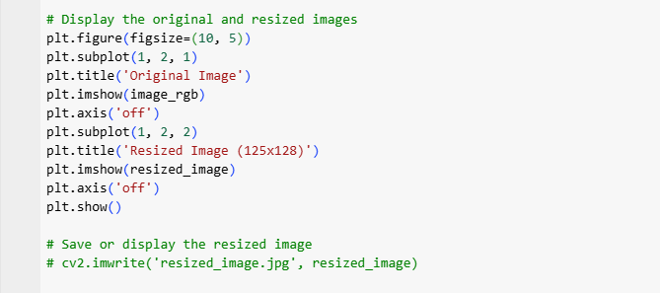

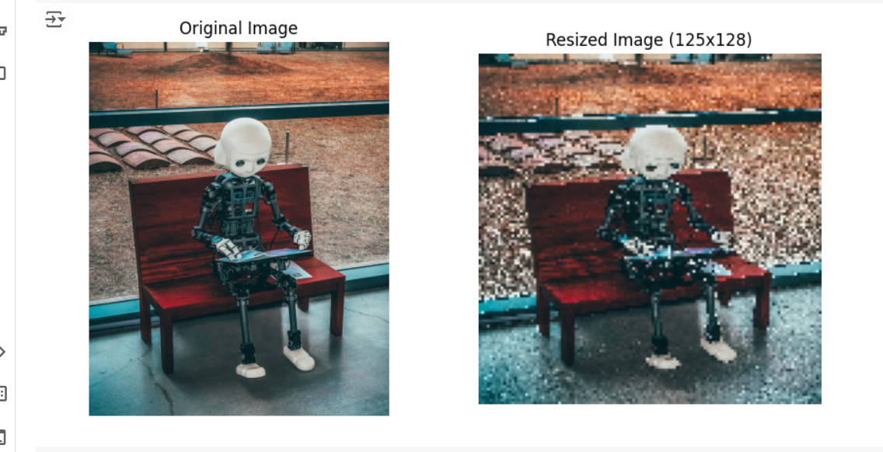

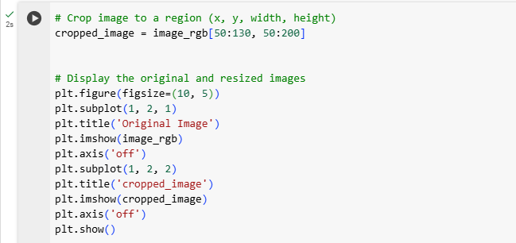

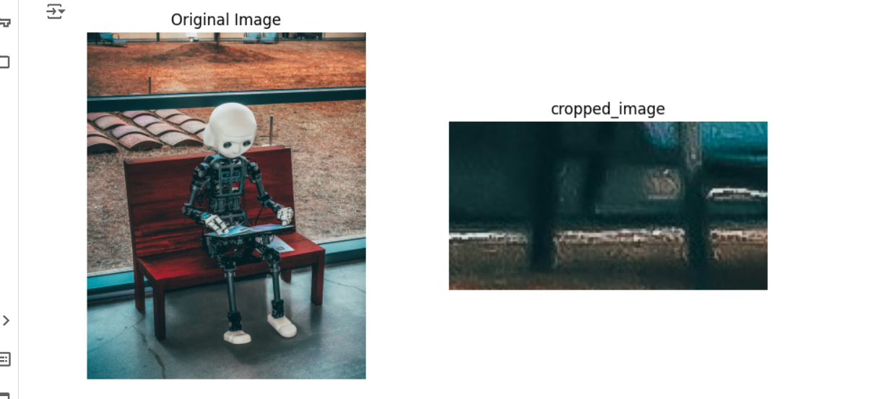

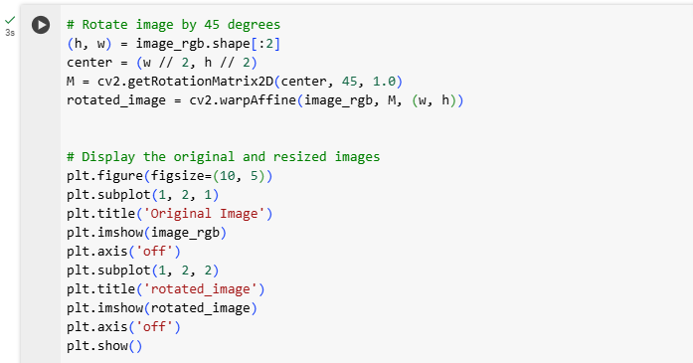

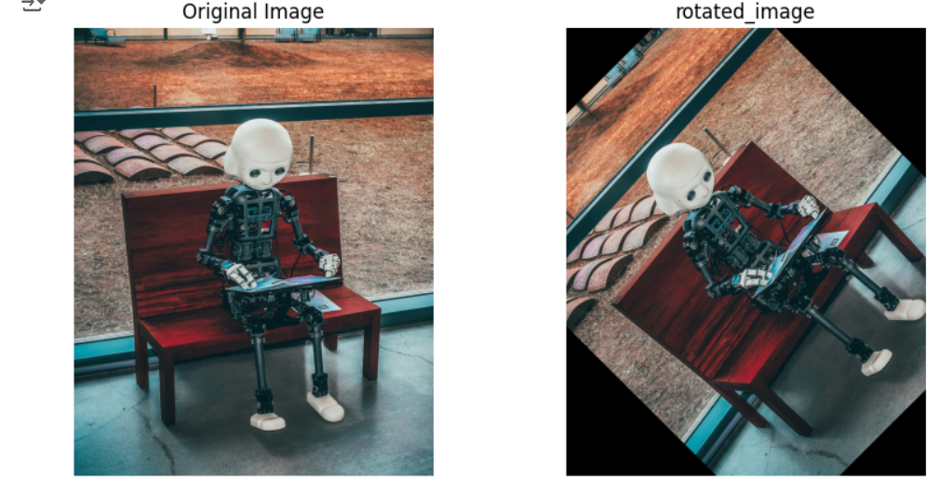

Activity 3

**Image Preprocessing Techniques**

* Image Denoising and Smoothing: Reduces noise and smoothens images to improve quality.
* Histogram Equalization and Contrast Enhancement: Enhances the contrast and brightness of images for better visibility.
* Image Denoising and Smoothing : These techniques reduce noise and smooth the image to enhance the quality.
* Denoising : Denoising removes unwanted noise from images.

Requirements

* Personal computer/laptop
* Google Collab

Procedure

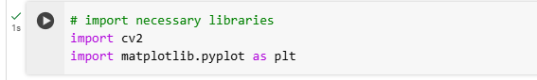

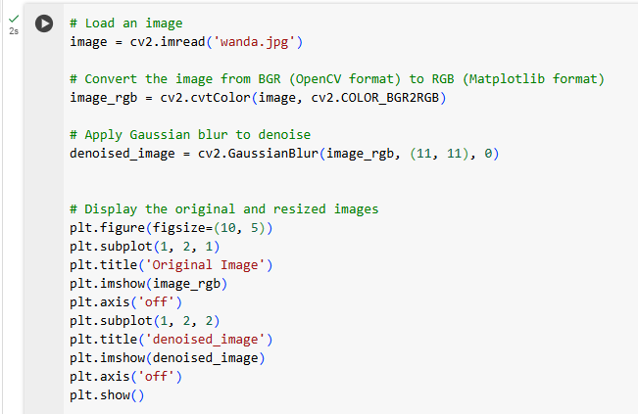

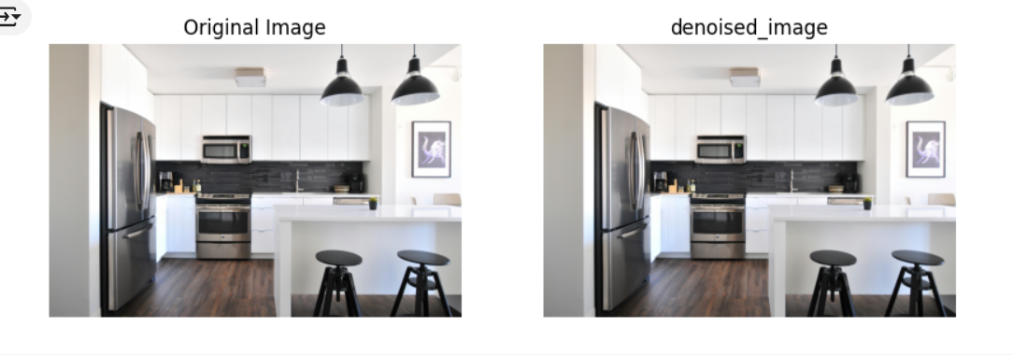

* Histogram Equalization and Contrast Enhancement These techniques improve the contrast and brightness of images.
* Histogram Equalization

Histogram equalization enhances the contrast of an image by spreading out the most frequent intensity values.

